**Application Technical Scope**

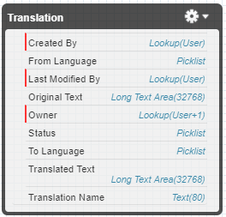**Data Model:**

**In terms of objects, there’s only one created for this challenge called Translation__c.  
 Nothing additional was needed for the suggested application.**

**Technical Scope:**

As for the technical part, two components were created, one for translation requests submissions (Translator.cmp), and another one to see a list of 10 requests made and stored in the custom object (TranslationRequestsViewer.cmp), together with their controllers (both Lightning and Apex), and their Helpers.

To make the app scalable, two additional classes were created, one to handle HttpRequests (TranslationCalloutService.apxc), and another one to parse the JSON received from the request (ResponseDecoder.apxc).

Nothing more, code-wise, was created to meet the requirements of the challenge.

**Use Cases:**

There’s room to progress with this app. The endpoints could be stored in Custom Settings (ex: Production, QA, Staging, etc).

Languages can me moved to the code in case of expansion of the supported languages.

The Request Viewer can be improved with a Refresh button, or to use Streaming API to detect changes in the status.  
 Also the Submit button can trigger the opening of a new SF tab to see the newly created record.